Output :

1.Creating file using nano and compiling the code using gcc commandImage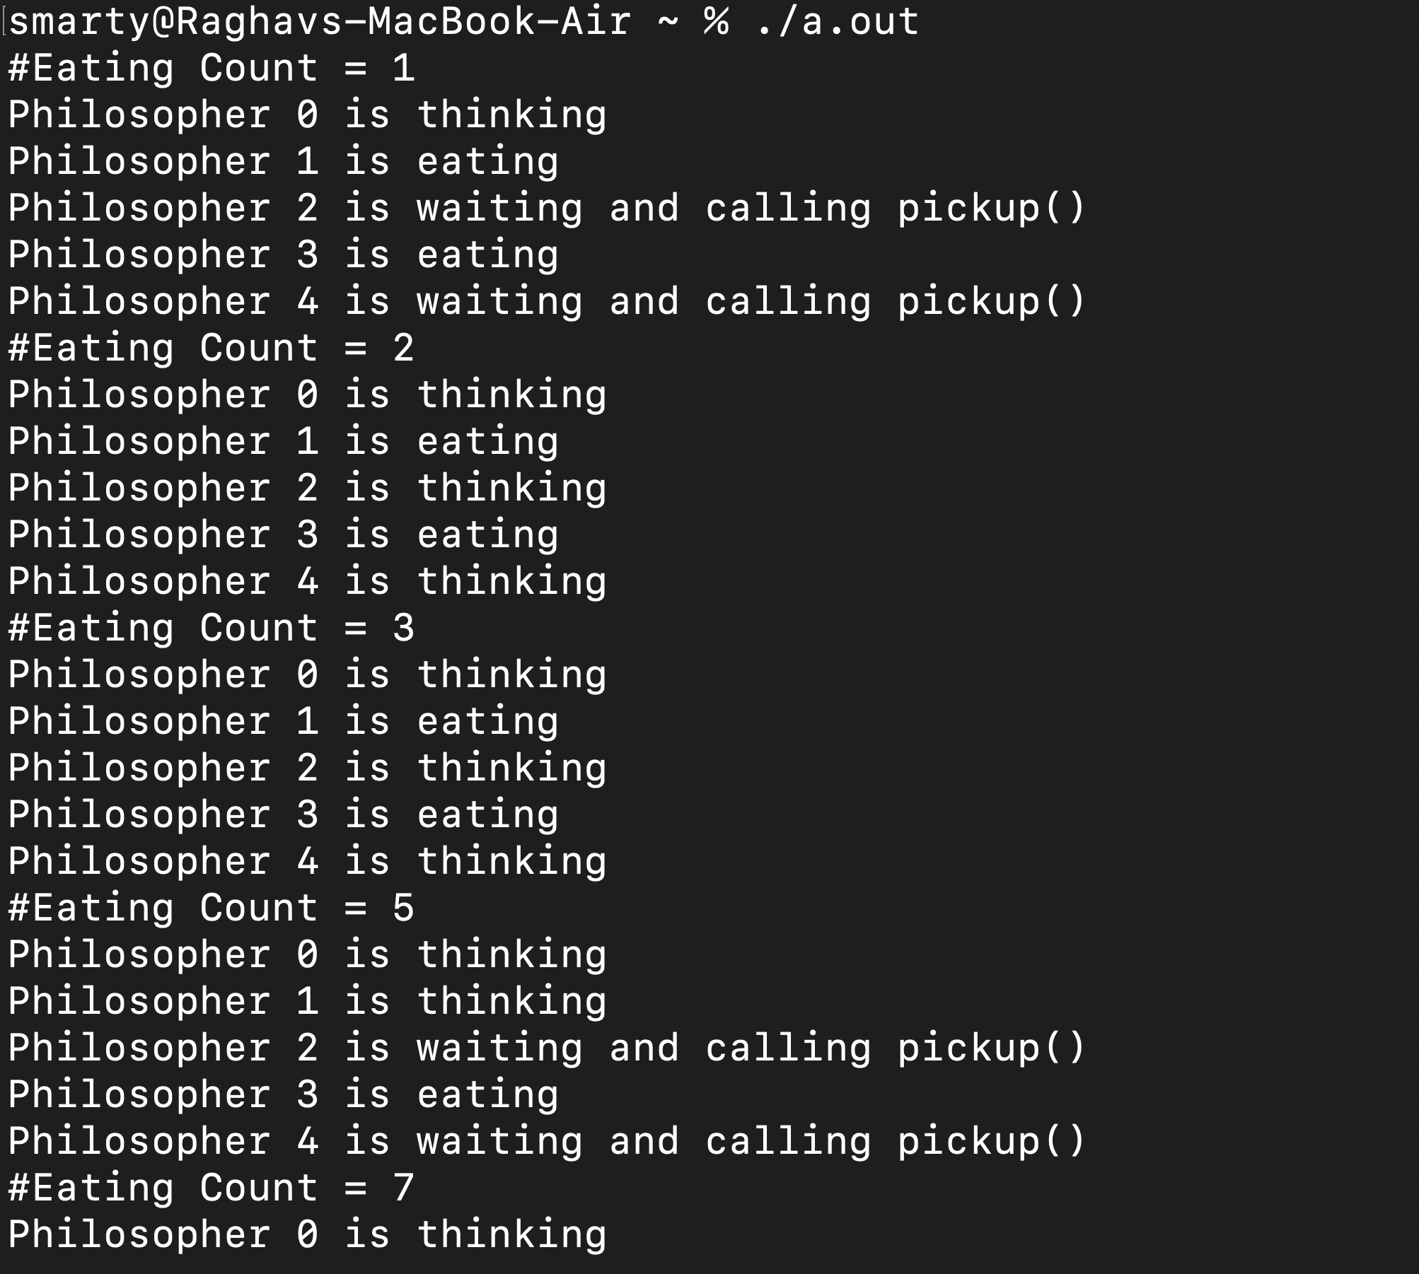

2. Running the code using ./a.out command.

3. Outputs for Dining Philosophers Problem:

